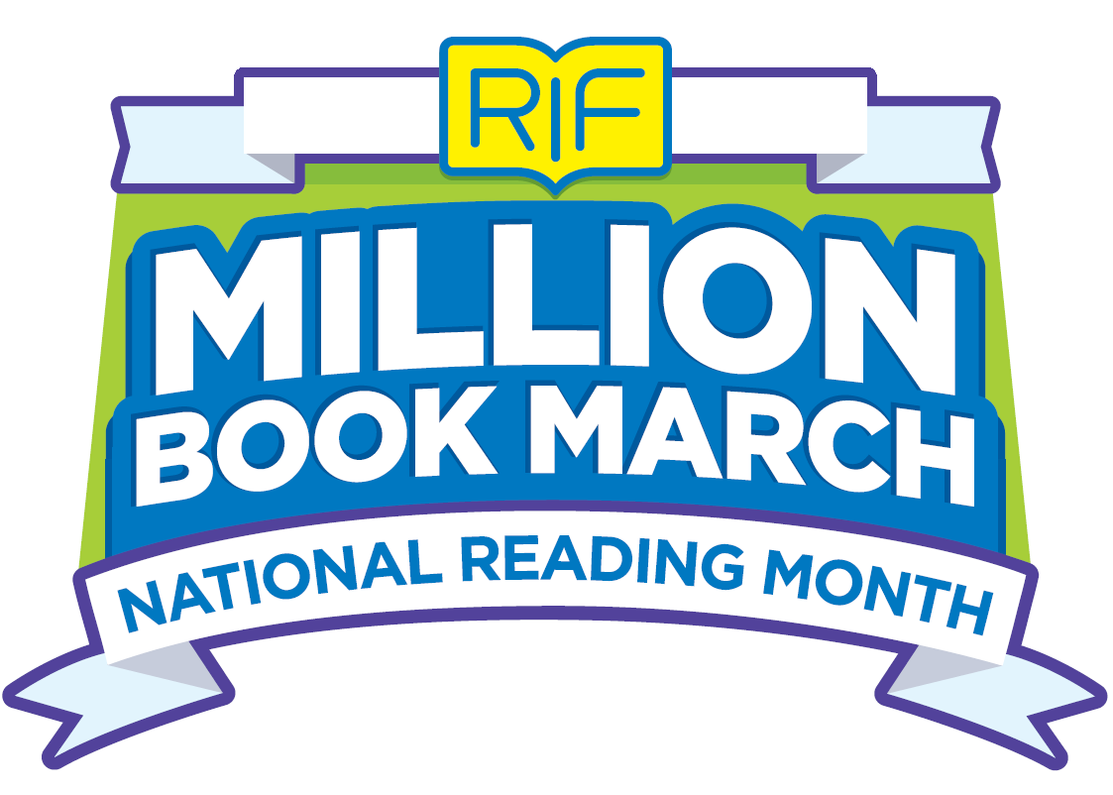

# Social, Newsletter & email posts

Reading Is Fundamental has made it easy to be a part of RIF’s Million Book March and to share the fun surrounding National Reading Month, March 1-31, 2018. Below are sample outreach messages for you to easily use in your own communications platforms and tactics.

How to use:

1. Copy and Paste your favorite message into your social feed, email or newsletter
2. Replace the highlighted copy with your personalized copy
3. Add your own picture/ image to make the copy interesting & deepen engagement. You can always add the Million Book March logo.
4. Post or Send!

**SOCIAL Post Suggestions:**

Facebook:

1. <<SCHOOl or COMMUNITY PARTNER NAME>> is excited to celebrate Reading Is Fundamental’s (RIF) Million Book March to get kids reading and count a million books read nationwide. Visit RIF’s Book Counter to tally your books now! [rif.org/millionbookmarch](http://www.rif.org/millionbookmarch) #everybookcounts
2. Make every book count this National Reading Month by visiting Reading Is Fundamental’s Book Counter. Read a book, tally it on the book counter and see if <<SCHOOl or COMMUNITY PARTNER NAME >> has made the READERboard. [rif.org/millionbookmarch](http://www.rif.org/millionbookmarch) #everybookcounts
3. Help <<SCHOOl or COMMUNITY PARTNER NAME >> top the READERboard on Reading Is Fundamental’s Million Book March. Tally books on the online counter at [rif.org/millionbookmarch](http://www.rif.org/millionbookmarch). #everybookcounts
4. Celebrate Million Book March with <<SCHOOl or COMMUNITY PARTNER NAME >> and Reading Is Fundamental! Head over to RIF’s Book Counter to join others and help count 1 million books read! [rif.org/millionbookmarch](http://www.rif.org/millionbookmarch) #everybookcounts
5. How are you celebrating National Reading Month? Join <<SCHOOl or COMMUNITY PARTNER NAME >> and Reading Is Fundamental for Million Book March by heading to RIF’s book counter where you can help us tally 1 million books read. [rif.org/millionbookmarch](http://www.rif.org/millionbookmarch) #everybookcounts
6. <<I/WE>> just counted XXXX books on Reading Is Fundamental’s Million Book March book counter? How many books will you record by the end of March? [rif.org/millionbookmarch](http://www.rif.org/millionbookmarch) #everybookcounts

Instagram:

1. Reading Is Fundamental’s Million Book March is here! Join <<SCHOOl or COMMUNITY PARTNER NAME >> and RIF to celebrate by tallying the books you’ve read at rif.org/millionbookmarch #everybookcounts

2. Help Reading Is Fundamental tally 1,000,0000 books read during Million Book March. <<SCHOOl or COMMUNITY PARTNER NAME >> just added XXXX to RIF’s book counter: rif.org/millionbookmarch What book will you add? #everybookcounts

3. <<I/WE>> just counted XXXX books on Reading Is Fundamental’s Million Book March book counter? How many books will you record by the end of March? #everybookcounts

Twitter:

1. Our <<SCHOOl or COMMUNITY PARTNER NAME >> has joined Reading Is Fundamental’s Million Book March! We are helping to tally 1,000,000 books. rif.org/millionbookmarch #everybookcounts
2. Reading Is Fundamental’s Million Book March is here! Join <<SCHOOl or COMMUNITY PARTNER NAME >> and RIF to celebrate by tallying the books you’ve read at rif.org/millionbookmarch #everybookcounts
3. Help Reading Is Fundamental tally 1,000,0000 books read during Million Book March. <<SCHOOl or COMMUNITY PARTNER NAME >> just added XXXX to RIF’s book counter: rif.org/millionbookmarch What book will you add? #everybookcount
4. <<I/WE>> just counted XXXX books on Reading Is Fundamental’s Million Book March book counter! How many books will you record by the end of March? #everybookcounts

**NEWSLETTER Suggestion:**

<<SCHOOl or COMMUNITY PARTNER NAME >> and Reading Is Fundamental (RIF) are pleased to partner to celebrate National Reading Month with the Million Book March initiative. This new literacy initiative supports children reading as many books as they can throughout the month of March and having a <<TEACHER OR PARENT >> report~~s~~ their results on RIF’s exclusive book counter found at [rif.org/millionbookmarch](http://www.rif.org/millionbookmarch). See how our school stacks up nationwide by entering our school’s name to qualify for RIF’s ***Reader***board.

**EMAIL for Educators:**

**Subject:** Read and Help RIF Count a Million Books in March

**Header:** Join RIF’s Million Book March (feel free to download & insert the title treatment)

Reading Is Fundamental (RIF) is pleased to partner with you/with teachers/schools or partner with whom? to celebrate National Reading Month with our Million Book March initiative. This new literacy initiative supports children reading as many books as they can throughout the month of March and reporting their results on RIF’s exclusive book counter found at [rif.org/millionbookmarch](http://www.rif.org/millionbookmarch). See how your school stacks up nationwide by entering your school’s name and book count to qualify for our ***reader***board.

Designed to encourage your students to read and develop literacy skills, RIF’s Million Book March features a robust website providing easy, impactful and customizable resources to use in your classroom. Visit the site to access our helpful toolkit featuring easy to use templates for posters, flyers, social media, online banners, bookmarks and certificates.

Also explore the Literacy Central Million Book March exclusive reading collection featuring curated book selections from RIF’s evidence-based, reading intervention program Read for Success that makes reading relevant and relatable. Here you will find free activities, games, educator guide and videos to build vocabulary and comprehension during instruction time. Explore new ways to encourage and excite your students to read by being a part of this fun month-long campaign.

To learn more about RIF’s Million Book March and make every book count, visit rif.org/millionbookmarch.

Happy Reading!

<<YOUR NAME>>

**EMAIL for Parents/ Family:**

**Subject:** Read and Help Reading Is Fundamental Count a Million Books in March

**Header:** Join RIF’s Million Book March (feel free to download & insert the title treatment)

Reading Is Fundamental (RIF) is pleased to partner to celebrate National Reading Month with our Million Book March initiative. This new literacy initiative supports children reading as many books as they can throughout the month of March and reporting their results on RIF’s exclusive book counter found at [rif.org/millionbookmarch](http://www.rif.org/millionbookmarch). See how our school stacks up nationwide by entering our school’s name and book count to qualify for our ***reader***board.

Families always hear about the importance of children reading. Now, RIF wants to encourage your children to pick up a book each day in March and build healthy reading habits. RIF’s Million Book March features a curated recommended reading list from our research-based Read for Success collection. And when your child reads, you can print bookmarks, certificates and a monthly activity calendar to share the excitement of National Reading Month.

To learn more about RIF’s Million Book March and make every book count, visit rif.org/millionbookmarch.

Happy Reading!

<<YOUR NAME>>

**Everyone Can Be a Part of RIF’s Million Book March!**

While Million Book March was created to get kids reading, adults are an important part of helping them access, choose and engage with books during National Reading Month. Adults can join the fun by posting pictures on their social media sharing how they make #everybookcount. Also post using #RIFMillionBookMarch. Here are some samples.

**Sample - #everybookcounts Sample - #RIFMillionBookMarch**

 